**RULES FOR THE BOMB DIFFUSAL GAME**

1. **Instructions for Memory Game**

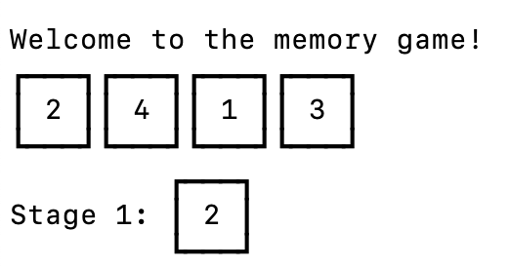

Type the correct number to progress the module to the next stage.

Complete all stages to disarm the module.

The first line of numbers are the key and the second line with the stage number is the display.

Number positions are ordered from left to right.

**Stage 1:**

* If the display is 1, type the number in the second position of the key.
* If the display is 2, type the number in the second position of the key.
* If the display is 3, type the number in the third position of the key.
* If the display is 4, type the number in the fourth position of the key.

**Stage 2:**

* If the display is 1, type the number "4".
* If the display is 2, type the number in the same position of the key as you typed in stage 1.
* If the display is 3, type the number in the first position of the key.
* If the display is 4, type the number in the same position of the key as you typed in stage 1.

**Stage 3:**

* If the display is 1, type the number with the same position of the key you typed in stage 2.
* If the display is 2, type the number with the same position of the key you typed in stage 1.
* If the display is 3, type the number in the third position of the key.
* If the display is 4, type the number "4".

**Stage 4:**

* If the display is 1, type the number in the same position of the key as you typed in stage 1.
* If the display is 2, type the number in the first position of the key.
* If the display is 3, type the number in the same position of the key as you typed in stage 2.
* If the display is 4, type the number in the same position of the key as you typed in stage 2.

**Stage 5:**

* If the display is 1, type the number with the same position of the key you typed in stage 1.
* If the display is 2, type the number with the same position of the key you typed in stage 2.
* If the display is 3, type the number with the same position of the key you typed in stage 4.
* If the display is 4, type the number with the same position of the key you typed in stage 3.

1. **Instructions for the Symbol Combination Game**

Only one row below has all four of the symbols from the keypad.

Type the four symbols in the order their symbols appear from left to right within that row. (case-sensitive).

|  |  |  |  |  |  |  |
| --- | --- | --- | --- | --- | --- | --- |
| A | ! | $ | ? | B | & | @ |
| b | M | = | > | 5 | U | x |
| } | W | Z | S | i | % | + |
| 3 | < | # | Y | T | 6 | H |

Example:

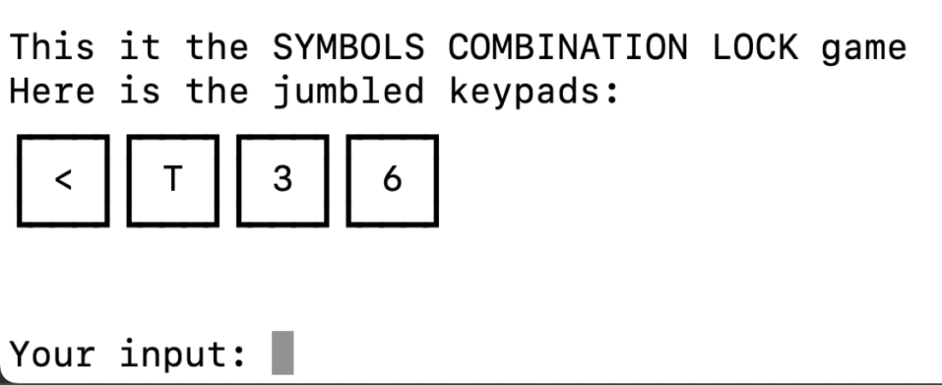

|  |  |  |  |  |  |  |
| --- | --- | --- | --- | --- | --- | --- |
| A | ! | $ | ? | B | & | @ |
| b | M | = | > | 5 | U | x |
| } | W | Z | S | i | % | + |
| 3 | < | # | Y | T | 6 | H |

The correct answer is: **3<T6**

1. **Instructions for Who’s on First Game**

1. Read The Main Word On The Screen.
2. Find The Row Where The Corresponding Word Appears First.
3. Find The First Word In The Corresponding Row That Appears On The Screen.

* Important: Input Is Case-sensitive.

EXAMPLE: ‘WRONG’ IS CORRECT BECAUSE ‘WRONG’[COL 2] APPEARS BEFORE ‘TIMER’ [COL 5]

1. **Instructions for the Wire module:**

* A wire module consists of 4-6 wires in it.
* There is **only one** correct wire number that should be cut to disarm this module.
* A wrong answer would cause a time deduction.
* Follow the sequence of rules.

**If there are 4 wires:**

If there is more than one red wire, cut the last red wire.

Otherwise, if the last wire is yellow and there are no red wires, cut the first wire.

Otherwise, if there is exactly one blue wire, cut the third wire.

Otherwise, if there is more than one yellow wire, cut the last wire.

Otherwise, cut the second wire.

**If there are 5 wires:**

If the last wire is black, cut the fourth wire.

Otherwise, if there is exactly one red wire and there is more than one yellow wire, cut the first wire.

Otherwise, if there are no black wires, cut the second wire.

Otherwise, cut the first wire.

**If there are 6 wires:**

If there are no yellow wires, cut the third wire.

Otherwise, if there is exactly one yellow wire and there is more than one white wire, cut the fourth wire.

Otherwise, if there are no red wires, cut the last wire.

Otherwise, cut the fourth wire.